Implementation documentation:

Code Folder Structure :

1. Data Sets : contains Keys and Data Files
2. Agents.pt : Marketing and Technical Agents
3. Intent.py : Intent Identifying Agent
4. Load_data.py : functions to read uploaded files data
5. Multi_Agent_LLM_Based_Customer_Service_System.py : main file to run the application
6. requirement.txt : contains all the necessary libraries

Function for Gradio UI and Activities :

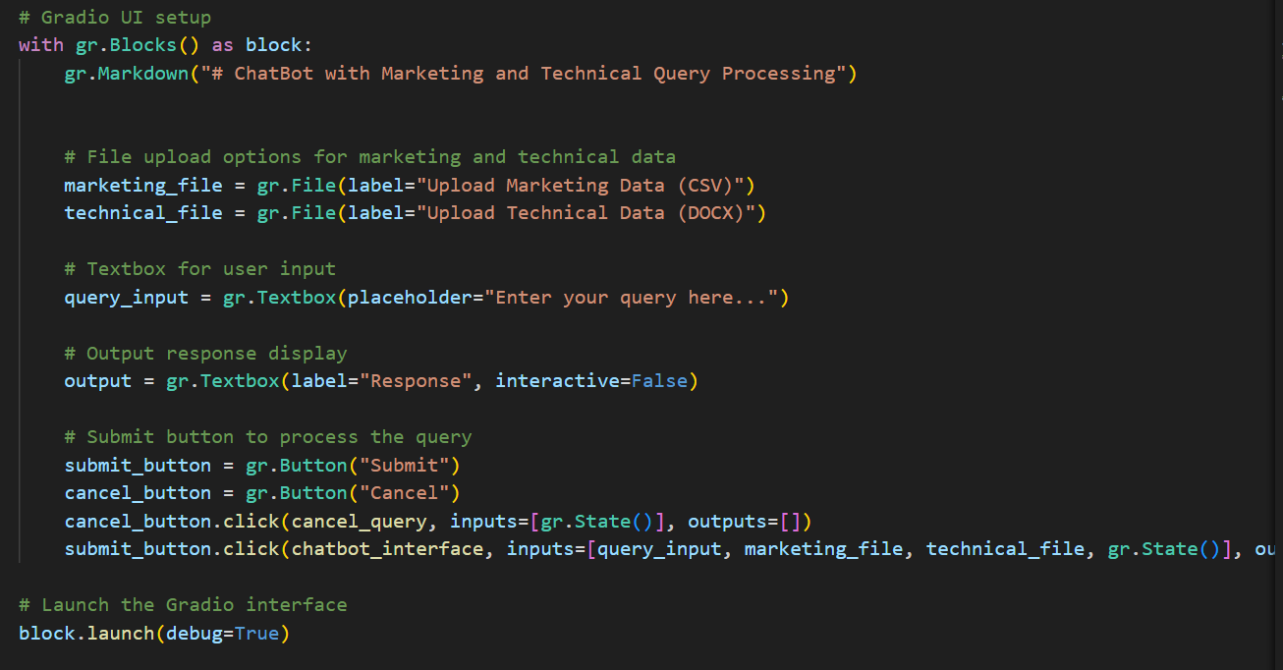

Handle Chatbot Logic and get response from agents and send to Gradio :

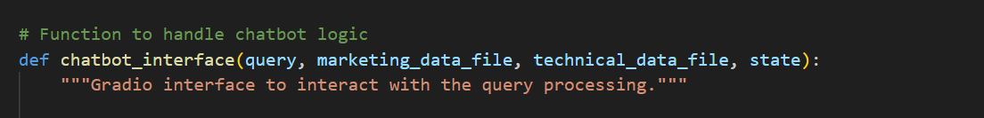

Marketing Agent: get Generated query. execute it on sqlite3 database and return response.

Technical Agent: use ai by sending prompt and return response

Generate_sql_query: Based on Marketing data and user query , this agent will create sql query to get proper response

Execture sql query in marketing agent:

Identify the query's intent and determine if it's related to marketing, technical, or both:

Recognize the query intent and route it to the appropriate agent(s) for a response:

Loads the Open API key from a JSON file and sets it as an environment variable:

Load Marketing and Technical Data files :

Function to upload CSV data to an SQLite database

